Lab 4:

Socket Programming Project 4 –

C Implementation of Client Server Communications

Vaukee Lee

CPE 138 - Computer Network and Internet

Professor Jun Dai

Goal:

In this lab, we will be C implementing a client-server communications that will greatly help us gain deeper understanding of the computer’s socket operations.

We must program a Client that reads a line of characters (data) from its keyboard and sends the data to the server; The server will receive the data and display it to its screen.

This image is the snippet of my TCP client and server running in C.

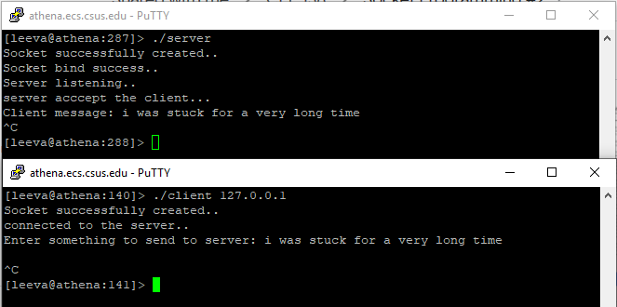

Conclusion:

This lab was quite fun to do. I was stuck for a very long time as you can see from my message in the image above. My server side was not working for the longest time. The problem was that it had successful binds, socket creations, and listens but it would not accept the client. The client would be able to connect to the server but it would later say pipe closed. I later found the problem though. It was this function that was provided to us: “int accept (int socket, struct sockaddr *address, int *addr_len).” I found that the “int *addr_len” is a “socklen_t *” (pointer type def or something along that line). I later found that I would have to save the length of “sin” to a new variable “le” and then use its address in the parameter of the function to make it work. At first it was the code of something like this : (socklen_t *)&sizeof(sin). This would compile but it would not accept. I also had to add “#define sa struct sockaddr” into the program as well since it gave me errors.